Aunt Debbie’s Chili

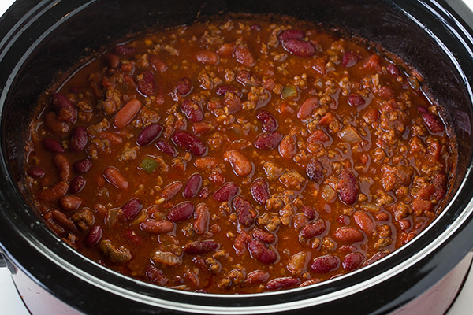

Ingredients

* 1 white onion, diced
* 1 ½ lbs. of ground beef, browned
* 1 can diced tomatoes
* 1 can tomato sauce
* 1 can of red kidney beans
* 1 can black beans
* 1 can pinto beans
* 2 packages of McCormick Chili Original seasoning

Directions

1. Brown the hamburger with the onions. Drain the fat.
2. Put all ingredients into Crockpot.
3. Cook on low for 8 hours.